# Chapter 2

The default destination for a given producer is set when the producer is created using the Session.createProducer() method. But this can be overridden for individual messages by using the MessageProducer.send() method

As noted earlier, a non-JMSclient uses a JMSprovider’s native client APIinstead of the JMS API

As depicted in figure 2.5, JMSmessages contain two parts, including headers and a payload. The headers provide metadata about the message used by both clients and JMS providers. The payload is the actual body of the message and can hold both textual and binary data via the various message types.

The JMSmessage is designed to be easy to understand and flexible. All the complexity of the JMSmessage resides in the headers.

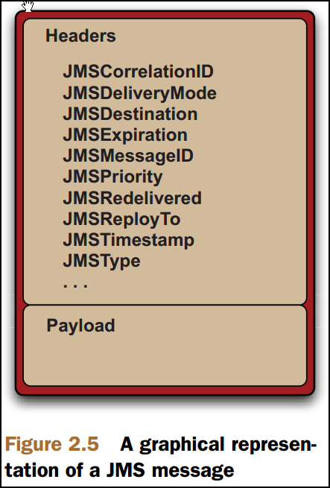

There are actually two types of headers, which are basically the same logical concept but differ semantically. Whereas a standard list of headers and methods to work with them are provided by the JMSspec, properties are designed to facilitate custom headers based on primitive Java types. Both are referred to generically as headers